# **MABS Speech to text analysis**

## **Google STT**

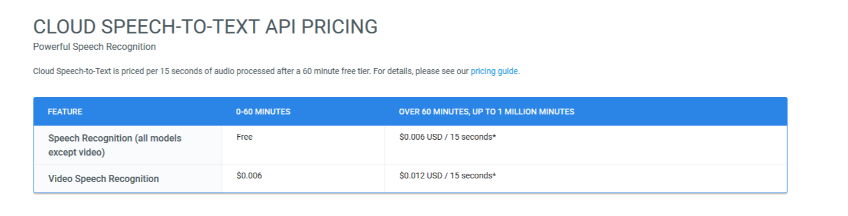Applies neural network models in order to capture the audio signal. The API recognizes 120 languages and variants. It can process real-time streaming or pre-recorded audio, using Google’s machine learning technology.

**Pros:**

* It supports 80 different languages.
* It can recognize audio uploaded in the request.
* It returns text results in real-time.
* It is accurate in noisy environments.
* It works with apps across any device and platform.
* Has Android examples of usage – easily integrable

**Cons:**

* It is not free (60 minutes free time)

**Accuracy** – Uses NN to learn the audio signal

**Cost** – 60 minutes free ($0.006 / 15 seconds | $0.024 / minute)

**Accessibility** – Android / iOS / Web APIs

**Reliability** - Constant access offline and online

## **IBM Watson STT**

Automatically transcribe audio from 7 languages in real-time. Rapidly identify and transcribe what is being discussed, even from lower quality audio, across a variety of audio formats and programming interfaces (HTTP REST, WebSocket, Asynchronous HTTP)

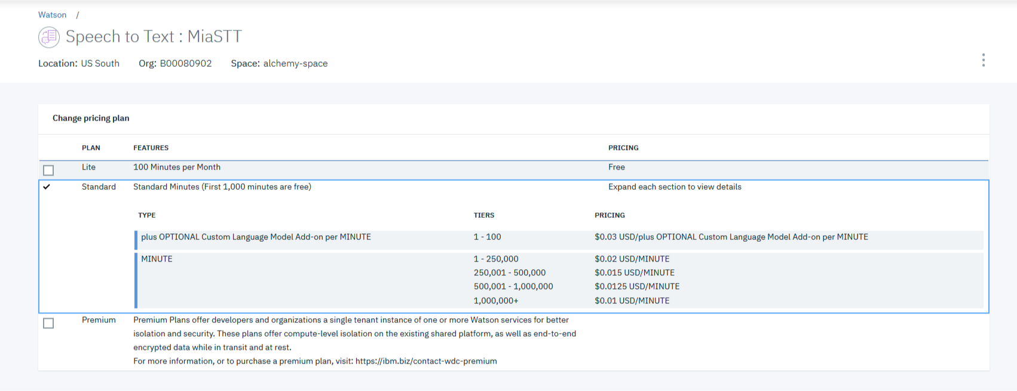Transcribe audio for various use cases ranging from real-time transcription for audio from a microphone, to analysing 1000s of audio recording from your call centre to provide meaningful analytics

**Pros:**

* It can be easily integrated
* Is highly accurate (same as Google)
* Uses patterns and learning models to learn
* First 1000 minutes are free / 100 minutes (full free plan)

**Cons:**

* Can be difficult to implement
* It is not free (60 minutes free time)

**Accuracy** – Modelled patterns to learn

**Cost** – 100 minutes free or 1000 minutes free and then ($0.03 / minute)

**Accessibility** – Android / Web APIs

**Reliability** - Constant access online